BIO of Robert B. Brownell
12403 NE 150th St
Woodinville, WA 98072 USA
425-577-1016
This document can be read online at www.DivineRevelations.info/BIO which includes all hyperlinks and images needed for verification.
I came to the Lord in 1991, and rededicated my life in the year 2000. Early in my Christian walk, there was a question that needed to be answered. Should I go to seminary and spend years studying the bible, and get a degree in Christian studies or should I just go out and start reaching the lost, and study as I go? I decided the latter, to fulfill the great commission, even if I didn’t go to seminary or have a degree behind my name.
One of the first ministries I joined was street evangelism. Going out and sharing the Gospel with anyone who would listen. Our church, Overlake Christian Church, developed a team called InsideOut. We reached thousands of people over the years, many of different nationalities. Our team would tour Seattle, DC, New York, and other cities, handing out Bibles, explaining the Gospel to the lost, giving food to the hungry, conducting praise street concerts, and praying for those in need. We are still going out, even after 17 years. I couldn’t have found a more loving and dedicated team as our InsideOut team.
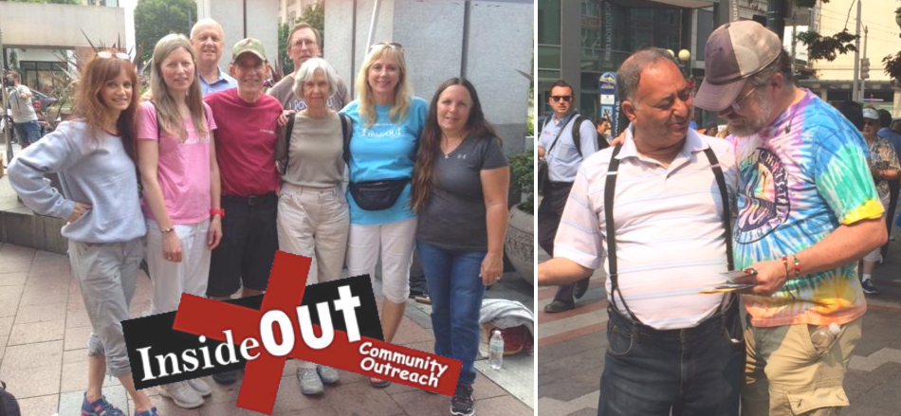
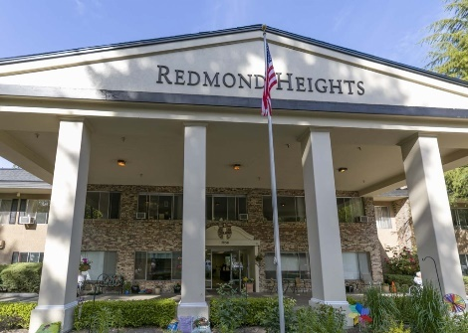
Soon my home Church, Overlake Christian Church, asked me to be the visiting pastor for Redmond Heights Senior Center. I was sent to minister to the elderly, conducting Sunday services, and praying for those in need. The elderly, who live in retirement communities, often have very different needs than most people. They need someone to listen to their stories, someone who cares, and will show them they have not been forgotten. I would often share the basic gospel message at the senior center, because for many of them it may be their last chance to make a decision for Christ. I continued in this Ministry for several years, until the time I moved to China.
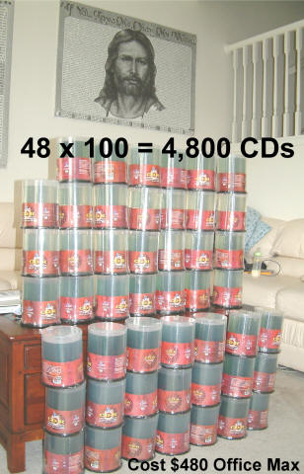
In 2001, my Christian life was transformed by hearing some powerful testimonies. One was by Bill Wiese, and another Mary K. Baxter. These testimonies were so urgent, so impactful to me, that I started a worldwide distribution center with 20+ volunteers under me. We made hundreds of thousands of CD copies, and sent them around the world, free. Many lives were touched, and countless souls were saved.
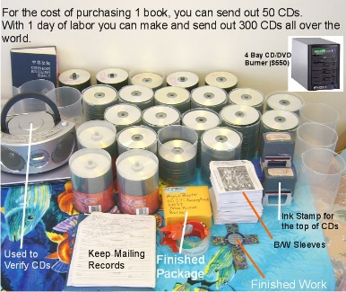
One parent even called to tell me about her son. He was on drugs and was away from the Lord for many years. One day while he was visiting his mom, she happened to be playing one of the audio CDs we gave her. Normally he would avoid listening to any kind of Christian message, but for some reason, he decided to stay in the room and listen. He was so touched by the testimony that he broke down, cried, repented, and came back to Jesus. The experience was so powerful to him that he decided he was going to share it with all his drug friends. Unfortunately, he died that night of heart failure. When the mom called me, she was so thankful that he came back to the Lord that day, and she said that he died with a big smile on his face.

My home church of OCC asked me to help run the Alpha Program. It was a tremendous opportunity to share the Gospel with people who might otherwise never attend church. In the many years I conducted Alpha, both in America and China, we brought hundreds of people to Jesus, and developed strong, lifelong relationships. Alpha is a 10-week course, which allowed us to teach on a variety of biblical topics, building people’s faith one step at a time. To be successful in Alpha, I needed to learn how to graciously handle every objection people have to Christianity.
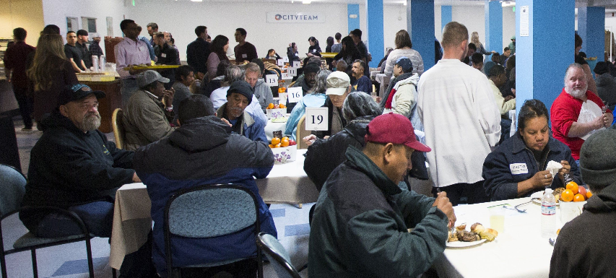
One of the best ministries a Christian can do is help the homeless. So I started volunteering at CityTeam Ministries. This was a great organization that would feed, clothe, house, disciple and serve the homeless. Volunteers would come in, cook and prepare the food, share a Christian message, pray and minister to the homeless. Over the years, I met so many precious saints there, great people who overcame enormous odds, and are now helping others. Volunteering there was one of the best experiences in my Christian walk. I even encouraged many other Christians to volunteer. This ministry continued until the time my family moved to China.
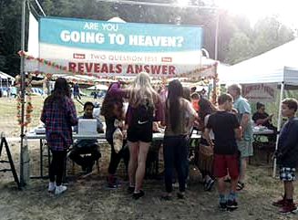
Since evangelism is my passion, I joined an organization called the GODMobile. We would go out to the different fairs, set up tents, and share the Gospel with the crowds. There are so many different people at fairs that we can reach tens of thousands of people each year, of every age, every nationality and every walk of life. It is truly a blessing to share Jesus with people, non-stop for several hours; even explaining the Gospel to little children in a way that they can understand. I’ll be joining the GODMobile seven times this summer 2019, reaching the lost for Jesus Christ.

Since the Lord blessed me with Computer skills, I started building Christian Websites around 2002. My goal was to get anointed Christian testimonies and teachings out to as many people as possible, in as many languages as I could. After years of searching, I’ve found some incredible stories of lives being transformed by Jesus, stories of people visiting Heaven and Hell, stories of vision and visitation of Jesus Christ. These include stories of X-Muslims, X-Witches, X-satanists, stories of Jewish people coming to Jesus, atheists coming to Jesus, Hindus coming to Jesus and even training on Spiritual Warfare. Each testimony encourages people to go deeper in their walk with Jesus, to avoid all the traps of the devil, and to go out and reach a lost and dying world. After 17 years of web development, this web ministry has reached over 30 million people. It is being viewed by over 70,000 people a day. And it distributes the Word of God (audio and text) to over 500 languages. God gave me a gift, give me 1 hour on a computer and I can reach 5000 people. Countless nights were spent developing this ministry and our YouTube Ministry, and it has really paid off. I will continue to build this ministry into the future. www.DivineRevelations.info / www.SpiritLessons.com
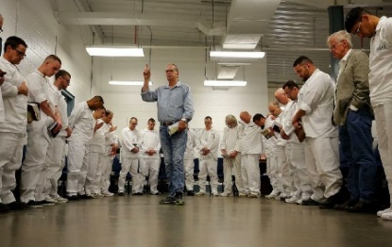
Around 2004, I joined the Full Gospel Businessmen prison ministry. We would go into the King County Jail and share the Gospel with the inmates. We were meeting drug dealers, gang members, thieves and killers. This was one of my favorite ministries because the men there, still in shock from losing their freedom, were very receptive to the Gospel message. We saw hundreds of men get saved and many others rededicate their lives back to Jesus. Now I’m working with PFC-Prisoners for Christ reaching the incarcerated men of Western Washington. I also volunteered with one of their sister organizations Angel Tree, which would visit the families of prison inmates to deliver gifts and the good news of Jesus Christ.
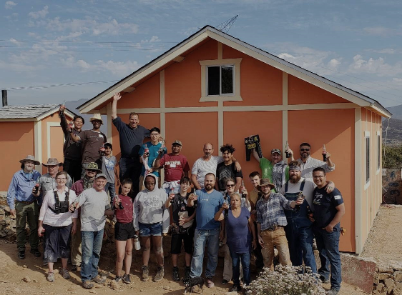
I have a son named David-Joseph-Joshua that was born in 2005. During the many years of Evangelism, I met several people who were raised in Christian homes, but then left the Lord, later in life. I am determined that this falling away will NOT happen to my son. In order to help his walk with the Lord, we send him to a private Christian school, and took him on Mission Trips to Mexico. We go with an organization called Club Rust, which voluntarily builds homes for people living in Tecate/Tijuana Mexico. This is a great ministry, helping the less fortunate, and sharing Jesus with the kids in their community. My son loves these mission trips, and we are planning on continuing with them into the future.
In the Year 2006, after much prayer, I took my family and moved to China to do full-time missions work. It was a big decision, leaving our friends, our home, our jobs, but it was one of the most important decisions I’ve ever made, investing 10 years of my life into Asia. We started in Beijing working with the underground churches, supplying Bibles and other needed Christian media. In China there are 3 types of Churches; #1 the Underground Church, #2 the Three-Self/government sanctioned church, #3 the International Church. I’ve found that many of the people in the government-sanctioned church were just as passionate about God as those in the Underground Church. Therefore, I worked with all 3 types of Churches for whatever was needed. Teaching and Training were greatly needed at the underground church, the basic Gospel message was needed at the sanctioned church, and discipleship, spiritual warfare and intercession were needed at the International Church.
I soon learned about the persecution in China, over the years I was taken away by the police about 8 times. Persecution can be frightening, but once you realize that Jesus is with you, you start to see it as an opportunity rather than a hindrance. Some of my biggest breakthroughs happened right after being taken away by the Police.
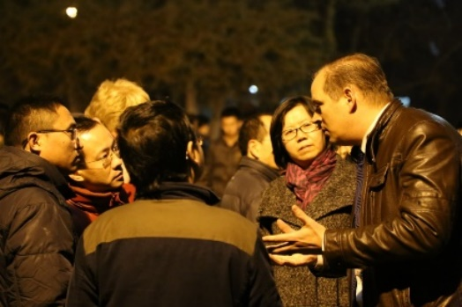
Every Friday I would do open-air preaching at an English corner. An English corner is a place, usually at Universities, where people come to practice their English, so we had more freedom there than at other places. Over the many years, I met thousands of Chinese people, mostly students, and shared the Gospel message every time. My style of sharing would often include showing them pictures on my iPad, making it easier for them to understand the Bible. We started five English Corners in different places around the city, which allowed us to go even deeper in our conversations about God. Many students were saved, got baptized and started attending Church.
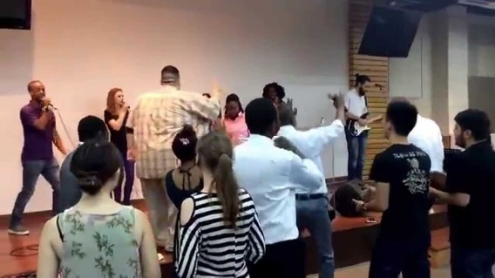
While in China we started a spirit-filled international Pentecostal church called ANIF – All Nations International Fellowship with Pastor Joseph Castillo. I was an assistant pastor serving the people of many different nations visiting Beijing. Our focus was to disciple Christians, getting them involved in the Gospel work that was needed in China. With over 1 billion people living in China, there is a great shortage of laborers. At our services there would be people from over 30 different nations. We would often need to change locations to avoid trouble, and on occasion, the police would come in and take away our facility.
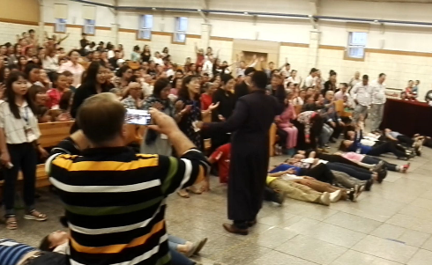
The great thing about living in China is that I could visit several other countries just by taking a train. We started ministering in Mongolia several years back, doing crusades, working with the local churches and even going into the prisons. Mongolia is a great place to minister because there is more freedom to evangelize and the people are hungry for a touch of the Spirit. Unfortunately, many of the children there are taken to temples by their parents and dedicated to their gods. Because of this, the ministry of deliverance is greatly needed there. But once a Mongolian gets a taste of Jesus, they quickly share it with many others. Our church, ANIF, has started daughter churches in Ulaanbaatar.
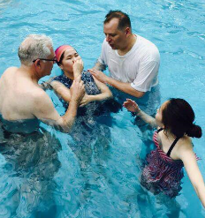
ANIF started a Mongolian fellowship in the cities of BaoDing and Wuhan. I was sent there to teach them the word of God and build their fellowship. It was a great experience working with Mongolian students and baptizing their new members. Since Mongolians quickly share their faith with others, we got to see many new believers come to faith. They had a good understanding of the basics of scripture, but often needed teaching about being Spirit filled, Spiritual Warfare, tongues and prophecy. Pastor Joseph Castillo made sure that we taught them good doctrine about spiritual gifts.
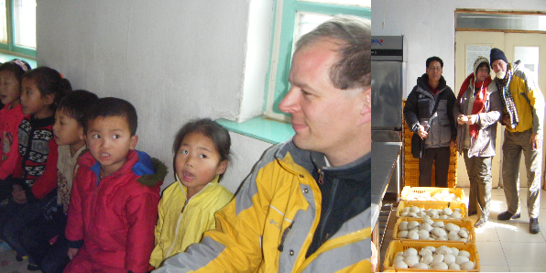
Another country I often visited was North Korea. I started volunteering for Manna Mission while living in China. We would buy wheat from China and bring it over to our bakeries in North Korea. These bakeries would provide bread for about 20,000 children each school day. With 6 bakeries throughout the country, we are able to prevent malnutrition for several of their elementary schools. There are many dangers for those working in North Korea, but God got us through each one. Serving North Koreans was a blessing I’ll never forget.
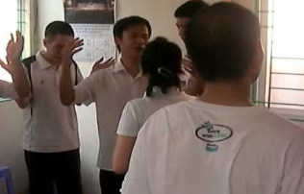
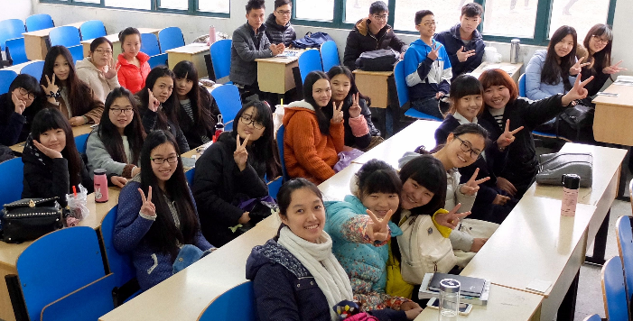
For several years I went on mission trips into Baotou and Hohhot, two major cities of China. Our team of teachers would be invited into the schools and universities to share our experiences. We would spend 3 weeks visiting many places and meeting the local students. The students were hungry for God, and we would share the Good News every chance we had. The students who accepted the Lord would allow us to baptize them at the local house churches. Our team, mostly from Seattle, would stay in contact with these students year-round and developed very strong relationships.
Our Beijing Church of ANIF sent mission teams into Vietnam and Laos to help build up the local churches there. These churches are in great need of pastoral training, Biblical teaching and training in how to use their spiritual gifts. We trained many of their leaders, and developed strong contacts needed for continual visits there. The Vietnamese and Laotian people are hungry for God, and eager to reach their communities for Jesus.

I move back to America around 2017 and am serving in my local congregation. Currently, I’m writing a book on Divine Healing. I believe that Jesus’ life was an example of how He wanted us to live; healing the sick, driving out demons, raising the dead, and preaching the Good news of the Kingdom. Jesus gave His Church power to do these things, but most of the Church is not walking in it. The goal of the book is to help people overcome the obstacles that have prevented them from entering the Healing Ministry. The book can be found at www.DivineRevelations.info/HEALING
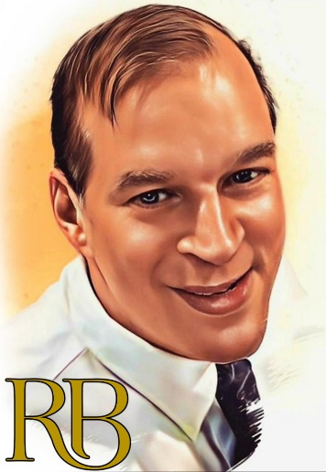
I was ordained as a Pastor while in China, by All Nations International Fellowship, and received my Chaplain’s license from Word of Life Christian Fellowship in 2018. I have also received my PHD Doctorate of Philosophy in 2019 (CICA) for 20 years of ministry.

Robert B. Brownell
12403 NE 150th st.,
Woodinville, WA 98072 USA
+1 425-577-1016

